**Application Programming Interface**



Components of an API:



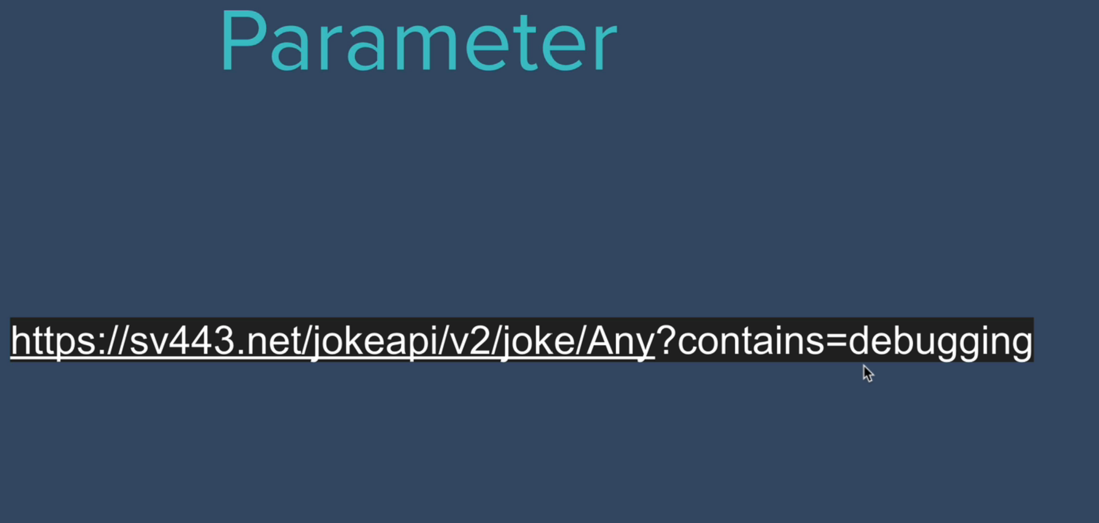



Upto joke: endpoint, /programming : path, after ? : parameters

Sv443.net/jokeapi/v2/

Formats to store data:

* Json: JavaScript Object Notation
* XML: Extensible Markup Language
* HTML, csv
* Json is popular because it formats data in a human readable format and also the data can be compressed to a great extent.

Functioning of an API

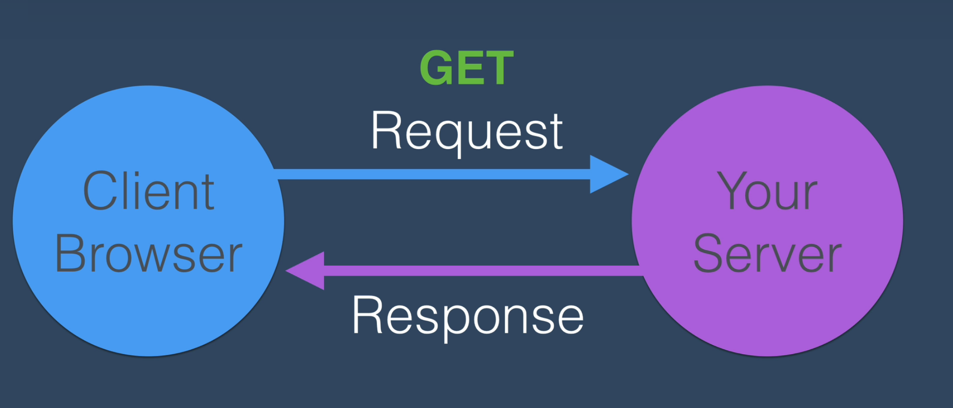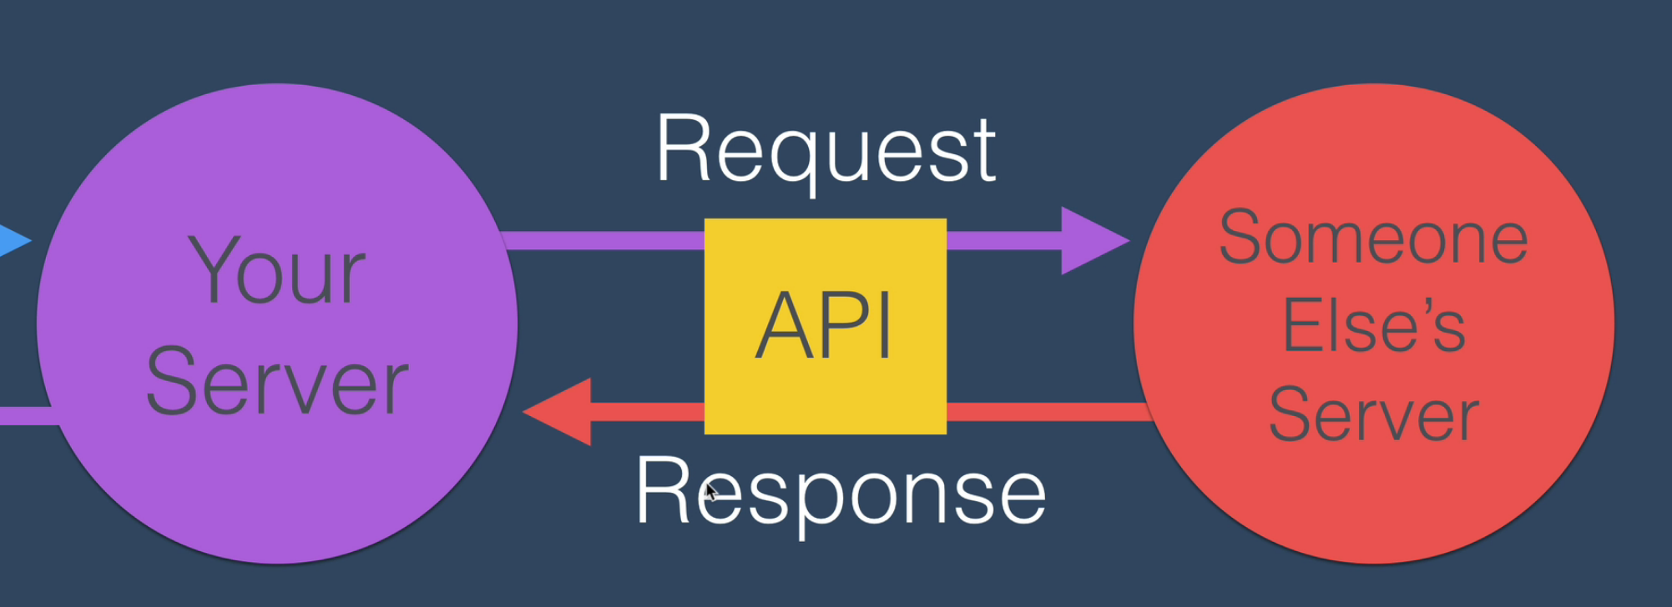

Making GET requests with node HTTPS module

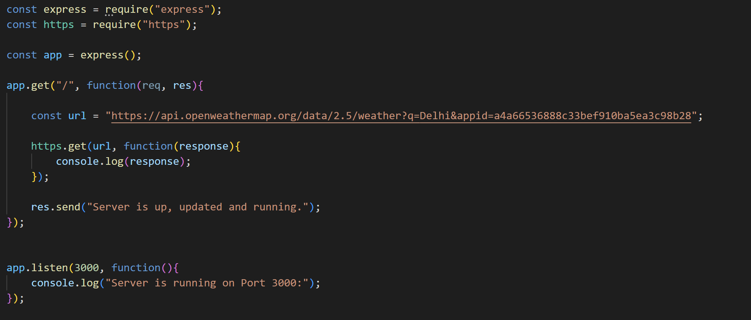

HTTP Response Codes

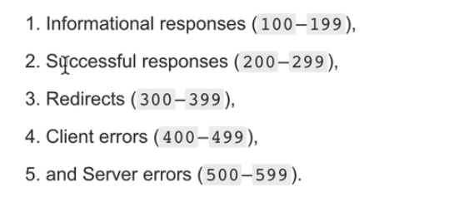

Parsing JSON

We can fetch the data returned by the API using ‘on’ method. The fetched data is present in hexadecimal form. So, we need to parse it in human readable JSON format.

* **JSON.parse(data)** is used to parse the data into JSON format.
* **JSON.stringify(data)** is used to change a data having a JSON format to a string removing all the unnecessary spaces. (Compression of the data)

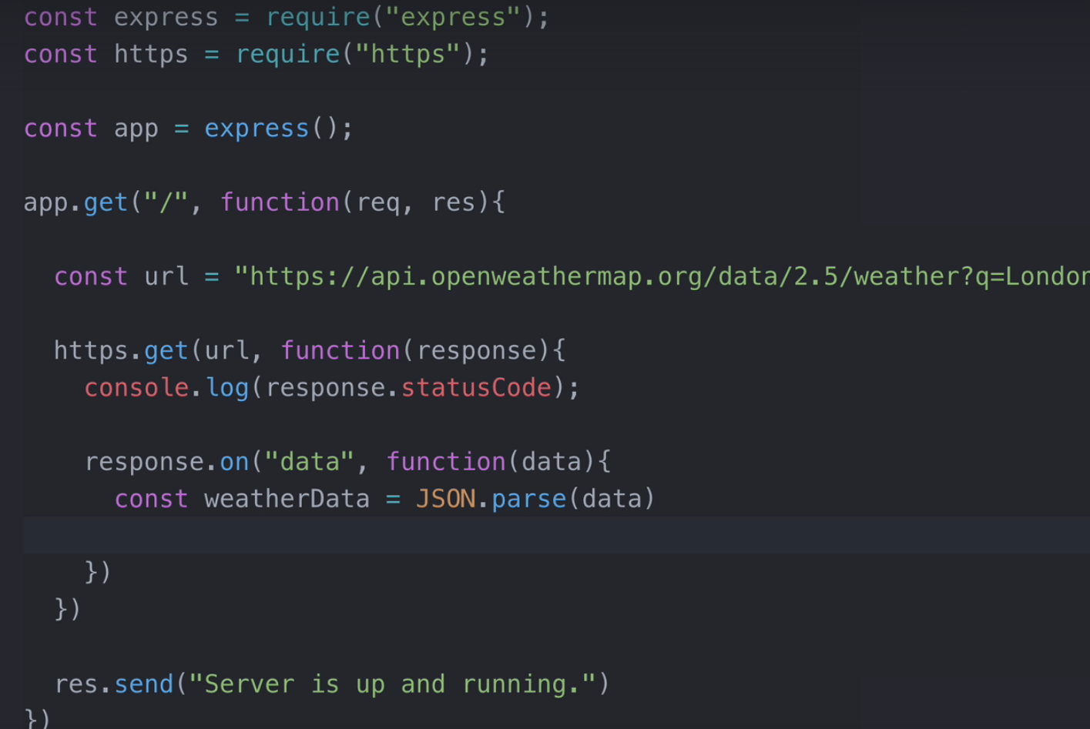

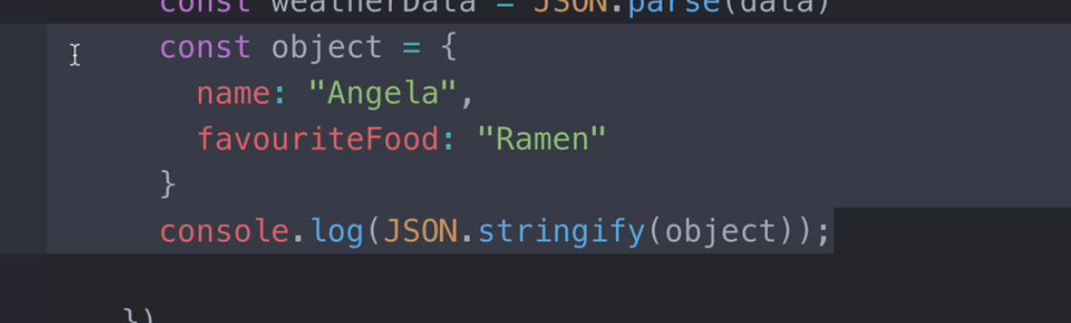

**Using Express to render a website with live API data**

We can get the required data as:

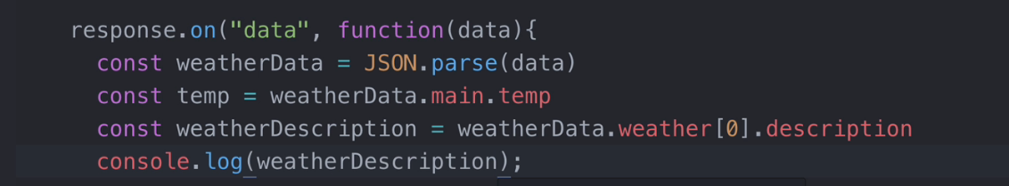

Note: While sending a response to a client, we use send method only once. So, to send multiple lines of data, we can use write method.

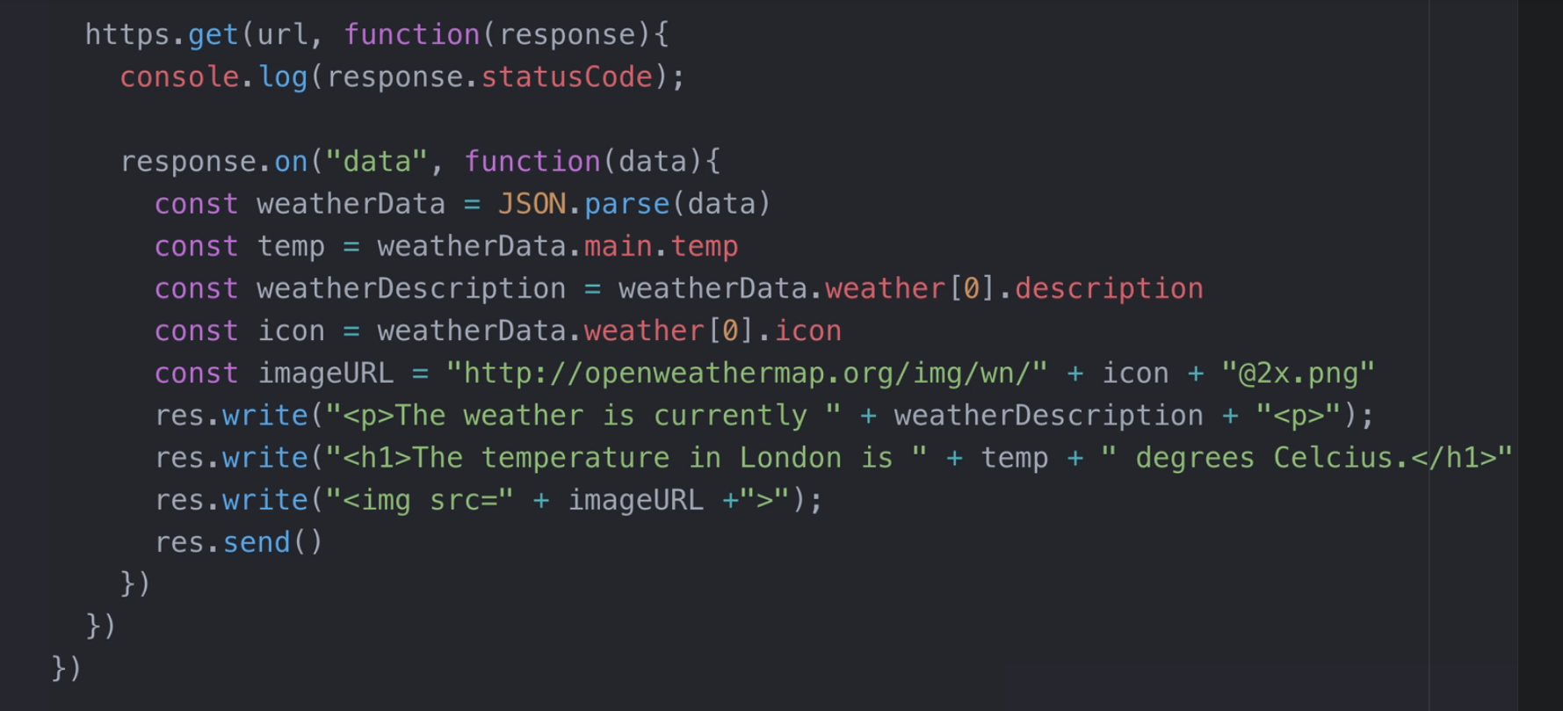

Parsing POST request to server using Body Parser

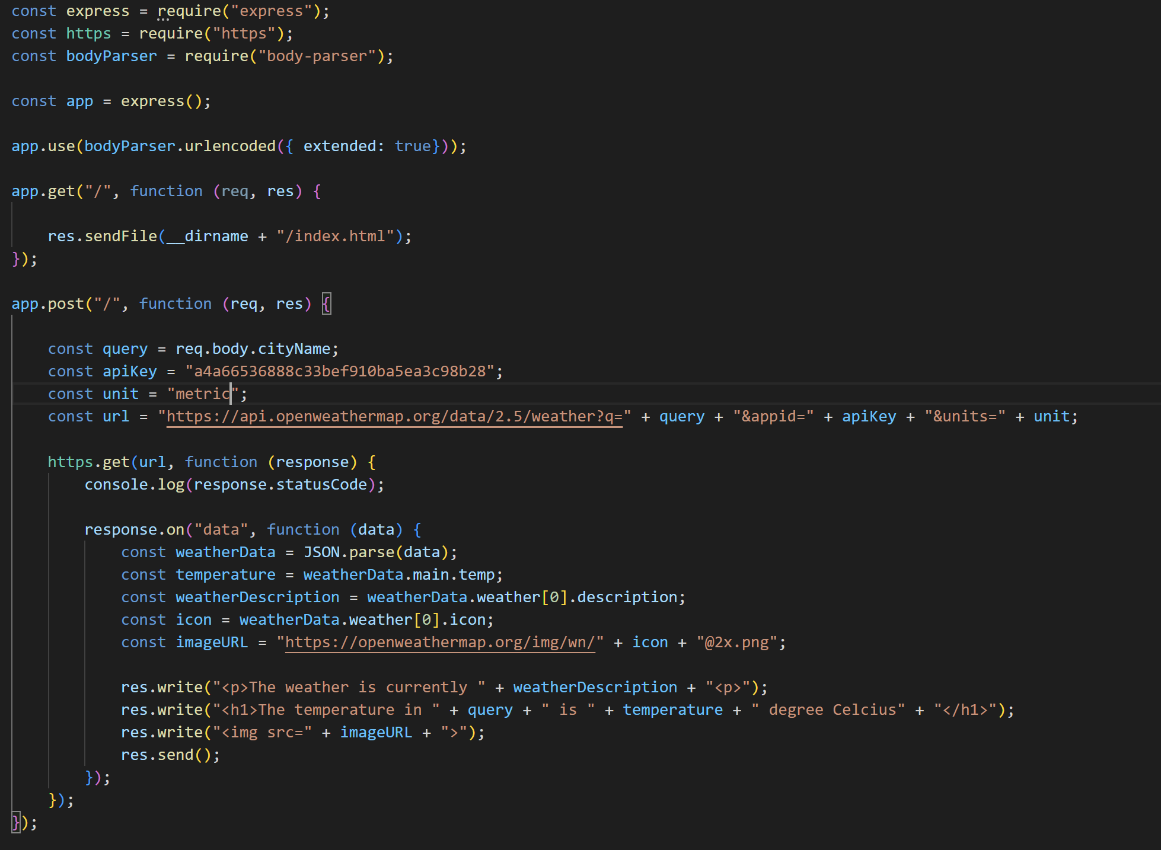

To ensure that our server uses the static or our local files such as images in our system or local CSS files, we use ‘static’ method.

**NewsLetter Project**

SignUp page

